Power BI Assignment 1 – Data Transformation & Data Modeling
Final Report (Summary of Work Done)
1. Data Import
The following datasets were imported into Power BI and loaded into Power Query Editor:
- List of Orders.csv
- Order Details.csv
- Sales Target.csv
All datasets were successfully loaded for transformation and modeling.
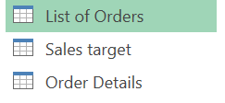

2. Row Limiting & Data Types
- Limited List of Orders table to first 500 rows.
- Changed data types:
  - Order Date → Date
  - Amount → Fixed Decimal Number
  - Target → Fixed Decimal Number
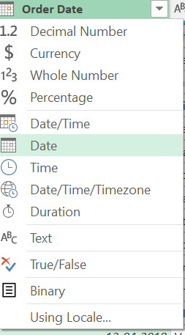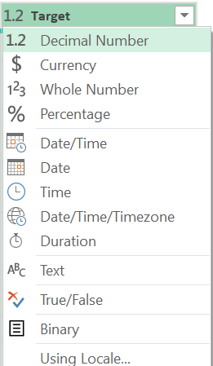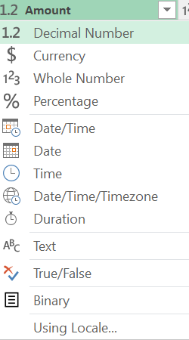
3. Text Formatting
- Converted Customer Name column into Proper Case for consistency.
Example:
john smith → John Smith
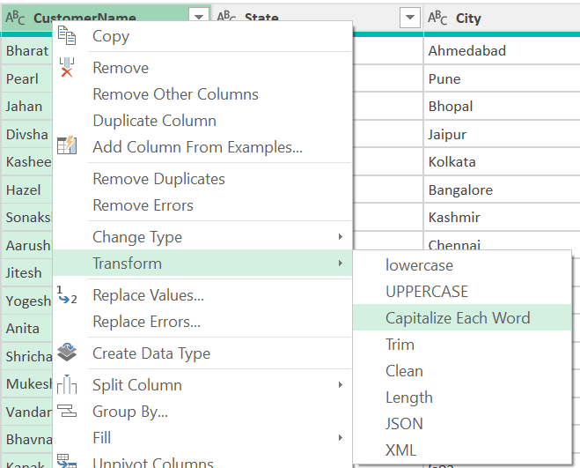
4. Column Creation
Location Column
Created a merged column:
Location = City, State
Example:
Chennai, Tamil Nadu
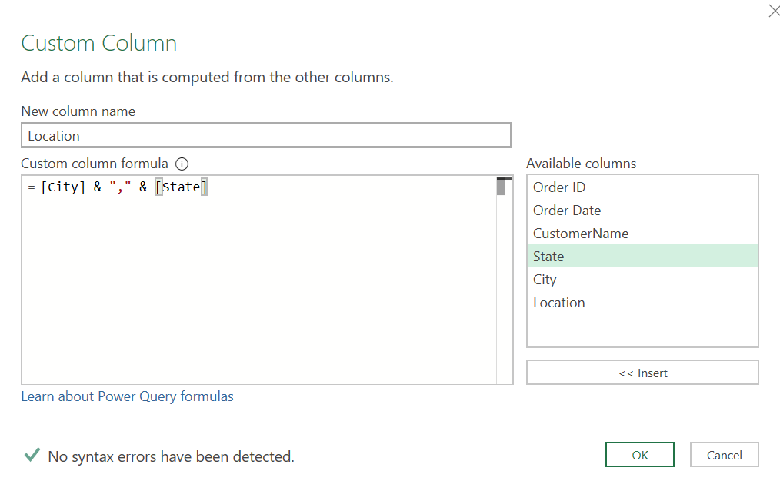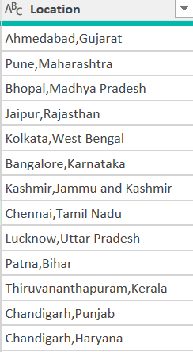
Profit Margin Column
Created custom column:
Profit Margin = Profit / Amount
Formatted as Percentage
Example:
0.25 → 25%
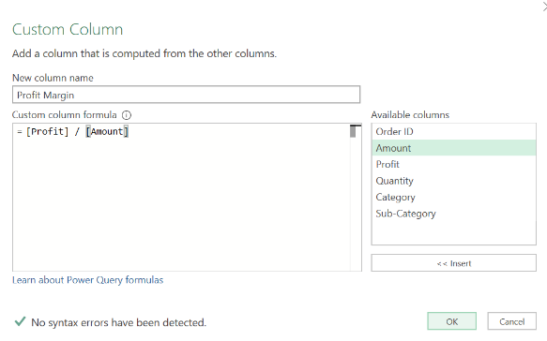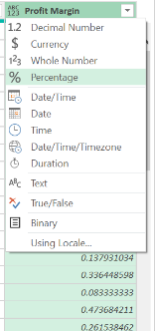

5. Conditional Column
Created a column Profit Status:
Condition | Output
Profit < 0 | Loss
Profit = 0 | Break-Even
Profit > 0 | Profit
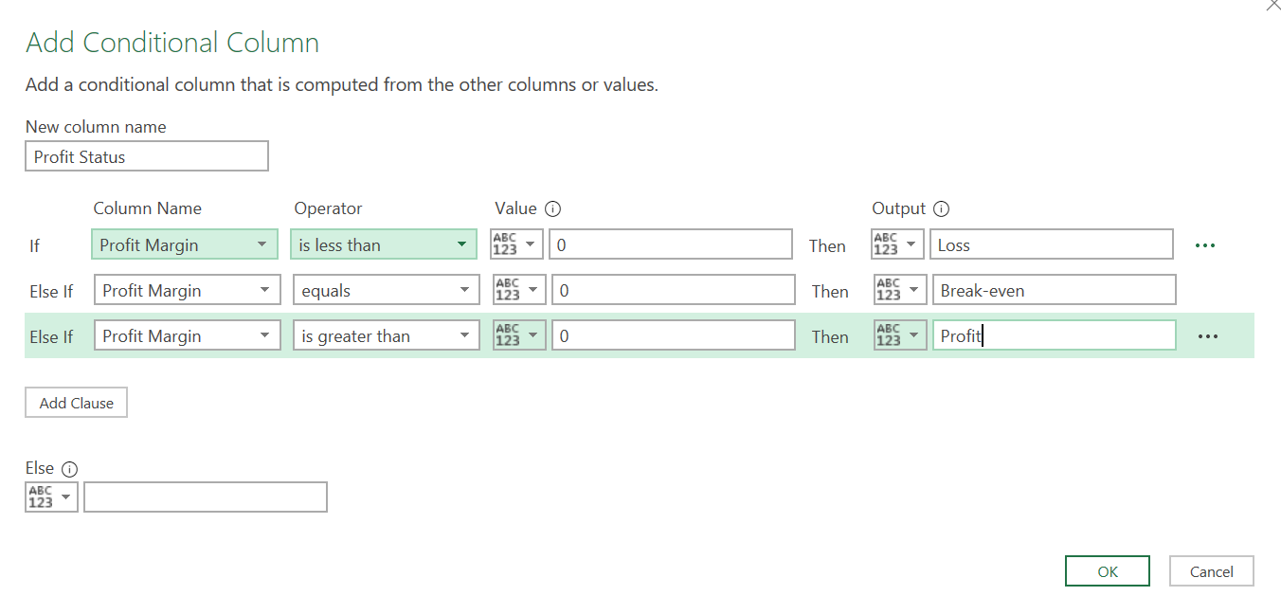
6. Data Merging (Joins)
Merged tables:
- List of Orders
- Order Details
Using common key:
Order ID
Created final table:
Orders Data
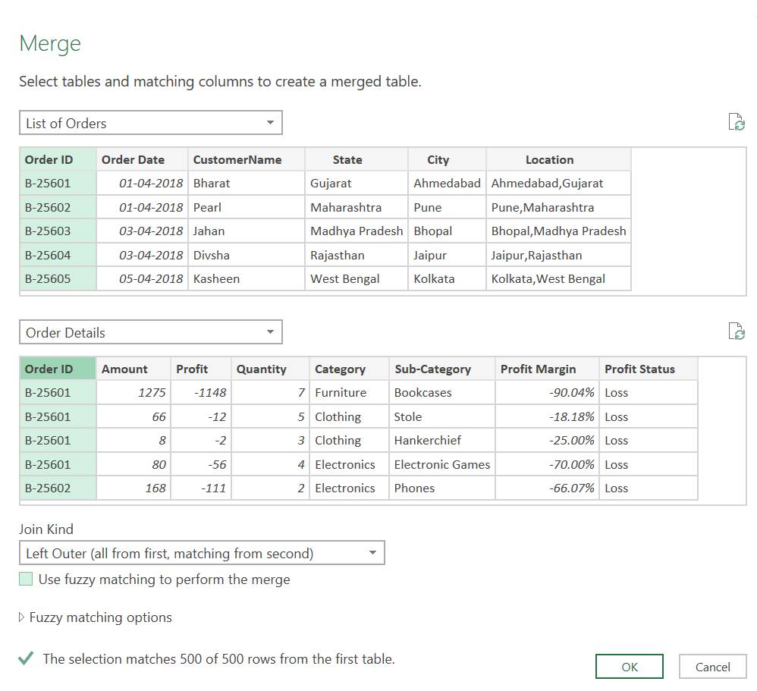
7. Handling Missing Data & Duplicates
Missing Data Handling:
- Identified null values using Column Quality.
- Replaced missing values where required.
- Removed unnecessary records.
- Retained nulls where data was optional and meaningful.
Duplicate Handling:
- Identified duplicate rows.
- Removed exact duplicates using Remove Duplicates.
- Retained valid repeated transactional records.
📌 Screenshot required: Column quality view / remove duplicates step

8. Sorting & Filtering
Sorting:
- Sorted Orders Data by Order Date (Descending).
Filtering:
- Applied filter on State = Tamil Nadu for analysis.
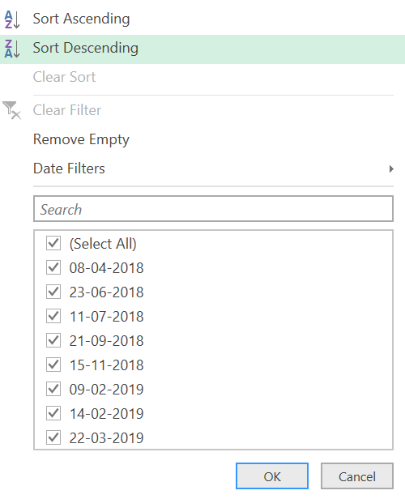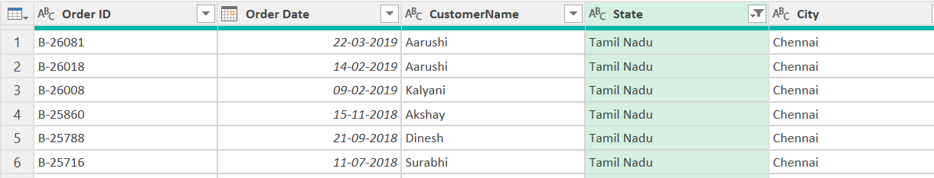

9. Grouping & Aggregation
(A) Count of Order ID
- Used Group By → Count Rows
- Generated total order count

(B) Average Profit by Category
- Grouped by Category
- Calculated Average Profit

(C) Total Amount by Sub-Category
- Grouped by Sub-Category
- Calculated Sum of Amount

(D) Sales Target by Month
- Extracted Month from Order Date
- Grouped by Month
- Calculated Total Target
- 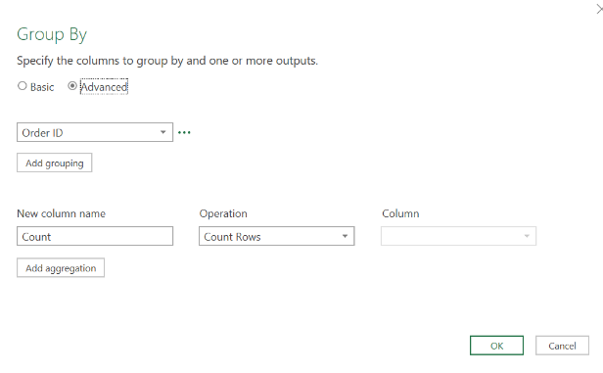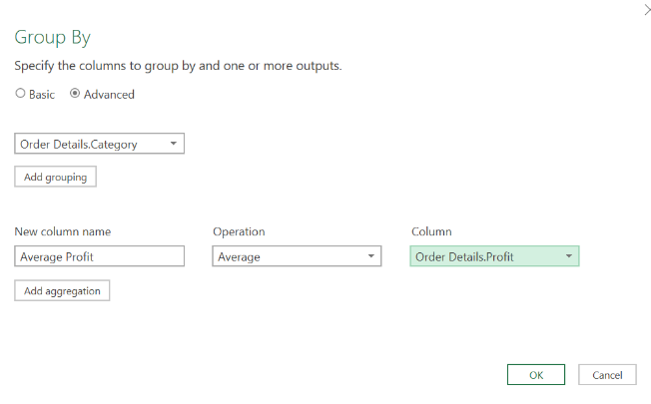
- 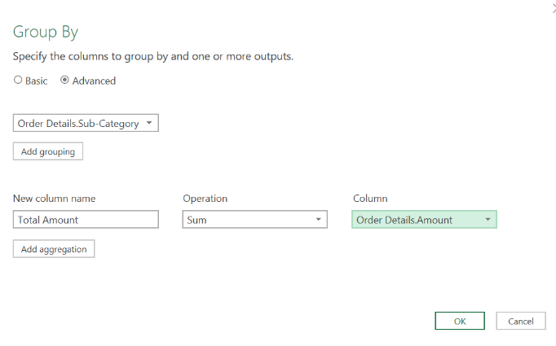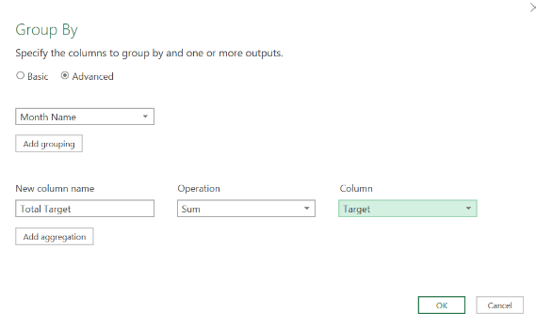

Final Outcome
A complete Power BI data model was built with:
- Cleaned and transformed datasets
- Merged and aggregated tables
- Proper handling of missing and duplicate data
Note: The Data Modeling task (creating relationships and Model View) was not performed because Power Query Online does not provide the Model View or support saving projects as .pbix files. All required data import, transformation, cleansing, merging, filtering, and aggregation tasks were completed successfully within the available environment.

